
BRIGHTON COMMUNITIES

Celebrating 25 years - Planning for the Next 25

Building the Neighborhood

Transportation Plan
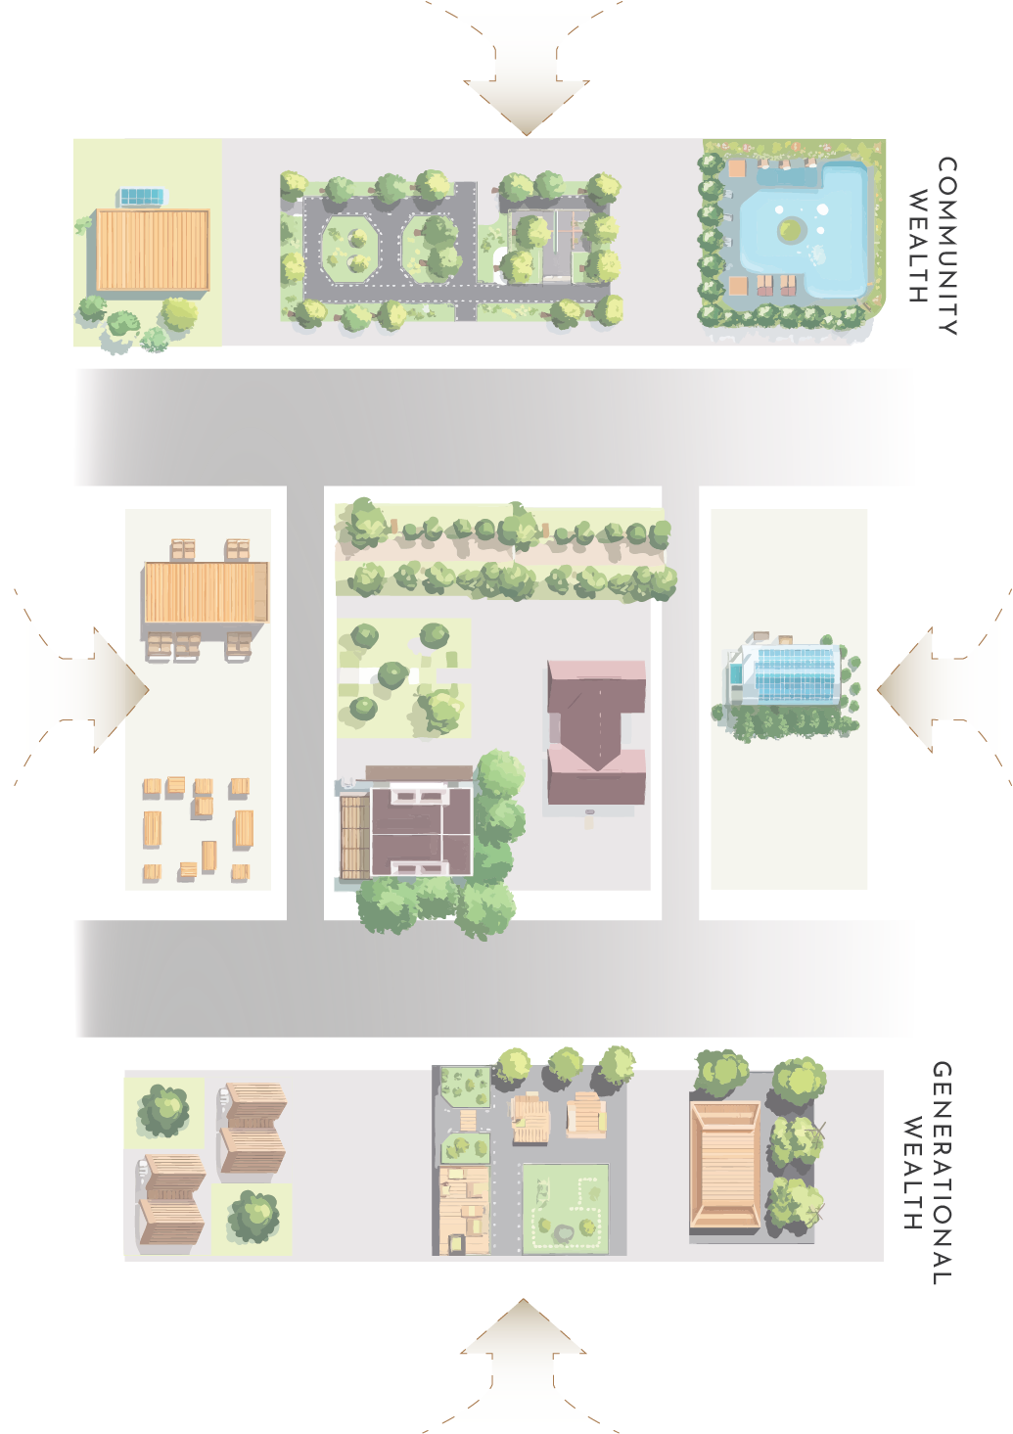
Why We’re Re-building the Corner that Holds Brighton Together

A Walk Down Holly & Rainier
Stand on Holly Street where it meets Rainier Avenue today and you feel the whole neighborhood trying to squeeze through a space that was never built for people. Worn, narrow walks tip toward the gutter; buses heave past at 30 mph; a parent with a stroller hesitates because the push-button pole sits six feet into the puddle. Yet just beyond the traffic you can hear the drum circle warming up at ADEFUA, smell late-morning injera at Rainier Mini-Mart, and spot Granddad waving from the Brighton Apartments balcony. All the life is here—but the street’s design still treats us like a place to pass through, not to gather.
Brighton’s next chapter flips that script. We are turning the Holly × Rainier crossroads into a front porch for the entire community—a raised, tree-lined civic room where catching the bus is as comfortable as catching up with a neighbor. The project is not a cosmetic “streetscape”; it is a piece of social infrastructure wired directly to our anti-displacement strategy:
- Walk first, ride second, drive last. Fourteen-foot sidewalks, continuous planter-bioswales, and a table-top intersection slow traffic to human speed and let a grandmother cross without racing the countdown clock.
- No-excuse access to work. A center-island platform knits Metro’s future RapidRide R with our zero-fare B-Line shuttle, guaranteeing a five-minute-headway link to Othello Station and 50 000 downtown jobs before sunrise shifts even start.
- Bright at midnight. New full-cut-off LED poles and waist-high bollard lights every 60 feet bathe crosswalks, bus shelters, and curb bulbs in even, shadow-free light so teens feel as safe walking home from practice as they do at noon.
- Culture lives at the curb. We set the Campus building back twenty feet, creating a micro-plaza where ADEFUA can host pop-up drum classes, Urban Family can run a bike-fix clinic, and street vendors keep Saturday mornings smelling like lumpia and coffee.
In short, the rebuild makes the main intersection tell the same story our housing and business projects already tell: Brighton belongs to those who live and work here. Concrete, signal timing, and planter soil become tools for wealth-building and well-being, not barriers. By 2029 every front door on the Campus will sit within a two-minute, weather-protected walk of a five-minute bus, and average travel time to Link will be cut almost in half—hard, measurable proof that a safer street is also a stronger job ladder.
The technical sheets that follow translate this narrative into curb radii, drainage details, and funding line-items. But the headline never changes: we are turning Holly & Rainier from a choke-point into Brighton’s living room, a place where movement, memory, and opportunity meet.
Below is a working playbook you can hand to SDOT (and our own design team) for the Rainier Ave S ✕ S Holly St “Central Hub” rebuild. I’ve tried to translate your must-haves into specific engineering actions, an approval path, and a funding logic. Let me know which details you’d like dialled in further—especially what you mean by “open Brighton Street” (re-establishing a vehicular connection east-west, or creating a woonerf through the campus?).

Design Objectives (non-negotiable)
Objective | How it shows up at the intersection
Safe & dignified walking space | Continuous 14 ft sidewalks (min) on all four corners, raised 6 in above gutter, with 8 ft clear zone, 4 ft furnishings/green strip, + 2 ft frontage zone for cafés and kiosks.
Zero-barrier job access | - 40 ft centre-island bus platforms (both directions) sized for future RapidRide R Line and B-line shuttle.  - Signal priority + 90 sec cycle length so buses hit ≤ 20 sec average delay—critical for 6 am shift starts.  - WAV-ready curb bay for Access paratransit and on-demand vans.
Strong night-time visibility | Full-cut-off LED poles every 60 ft, pedestrian-level bollard lighting on both crosswalk legs; lighting levels meet IES RP-8-21 “Downtown Pedestrian Way” class.
Predictable car flow (not fast, but smooth) | 3-lane Rainier template (one through in each direction + centre turn pocket), protected lefts (done 2019), and no slip lanes. Smart right-turn hold when pedestrians present keeps volumes moving without roll-throughs.
Local culture & retail frontage | 20 ft building setback on Brighton Campus SW corner to create a micro-plaza for pop-up vendors, ADEFUA performances, and weekend craft markets.
(Existing SDOT docs already confirm left-turn arrows and pedestrian timing upgrades at this location; now we layer the heavy civil work.) seattle.govseattle.gov

Geometry & Streetscape Package
Element | Spec
Raised, table-top intersection | 3 in height transition over 20 ft, flush with sidewalks. Forces 15–18 mph entry speeds yet still OK for Metro coaches (per SDOT/Metro raised intersection pilot at 23rd & Jackson).
Curb extensions / protected corners | 8 ft curb bulbs; radius = 15 ft for passenger cars, SB right radius = 25 ft (bus-friendly) using mountable apron.
Continuous green infrastructure | Bioretention planters along the 4 ft furnishing zone; dual function stormwater + buffer from traffic.
Signal logic | Leading Pedestrian Interval (LPI) 7 s; 20 s WALK + 10 s flashing countdown. APS push-buttons with locator tone (already noted in SDOT YVYC list). seattle.gov
Crosswalks | 20 ft zebra, epoxy aggregate; tactile pavers at curb ramps.
Cycle facilities | Two-way protected bike lane on west side of Rainier tying north to Graham “green street,” south to Brighton-Othello Trail.
“Brighton Street opening” (placeholder) | If reopening the platted Brighton Ave S between Rainier and 44th Ave: 26 ft shared lane, raised entry, one-way westbound (outbound) to relieve Campus parking load while keeping cut-through speeds low.

Project Development Road-Map
Step | Target date | Deliverable / decision
30 % Concept Plans | Jan 2026 | • Horizontal/vertical geometry • Drainage concept • Order-of-magnitude cost
SDOT Complete Streets & Vision Zero review | Mar 2026 | Green-light on raised intersection + bulb-outs (requires Transit Division concurrence)
60 % Design & Environmental | Nov 2026 | SEPA checklist; traffic ops memo proving Level-of-Service D or better for buses/cars across peak two-hour window
Right-of-way & utility clearances | Q1 2027 | Franchise utility vault relocation plan; PSE/Seattle City Light conduit for street-lighting
100 % PS&E & bid | Aug 2027 | Bid-ready set + engineer’s estimate
Construction window | Apr 2028 – Dec 2028 (9 mo) | Staged so one bus lane in each direction always open; night/weekend concrete pours for the raised table

Funding & Partners
Source | Est. $ | Notes
Move Seattle Levy 2 (renewal, 2025 ballot) | $3.5 M | Category: “Pedestrian Safety Corridors”
King County Metro R Line Access to Transit | $1.2 M | Corridor plan already highlights pedestrian lighting at Holly. kingcounty.gov
FHWA Safe Streets & Roads for All (SS4A) | $2 M | Raised intersection + LPI qualifies as systemic safety countermeasure.
Neighborhood Street Fund | $500 k | Community-submitted in 2026 cycle; leverages Brighton Communities volunteer match.
Seattle City Light Neighborhood Street Lighting | In-kind | Pole, conduit, energy costs.

Total construction cost (Class 4 estimate): $7.2 M.

“Jobs Access” Performance Clause
Because you said this is not optional, we bake job-access KPIs directly into the SDOT/Metro design agreement:
Metric | Baseline (2024) | Post-opening (2029) requirement
Walk-time from any Brighton Campus front door to a 5 min headway bus/shuttle stop | 4 min avg | ≤ 2 min
AM peak (6-9 am) one-seat ride opportunities to ≥ 50,000 jobs (Downtown + SODO) | 6 buses/hr | ≥ 18 buses/hr
Average in-vehicle travel time Campus → Othello Link | 13 min | ≤ 7 min

SDOT performance payments are tied to meeting these thresholds each year for the first three years of operation.

Next Steps
- Confirm scope of “open Brighton Street.”
- Choose sidewalk furnishing palette (street trees vs. continuous planter boxes).
- Meet SDOT Vision Zero team in August to confirm raised-table intersection is acceptable for Rainier’s bus volumes.

Parking & Curb-Space Strategy
(making room for cars without letting cars run the room)
Brighton’s streets already serve more functions than any curb can comfortably hold—bus stops, paratransit, deliveries, scooters, car-share, café seating, and yes, private parking. Rather than wage an endless tug-of-war for the same 22 feet of asphalt, we are treating parking as a managed community asset with clear rules that match the way neighbors actually live and travel.

1 | Create the Brighton Access Parking District (BAPD)
- Restricted Parking Zone (RPZ)—apply Seattle’s proven RPZ toolkit to all residential blocks within ¼-mile of Holly ✕ Rainier. Residents receive low-cost permits; commuters and arena-goers are limited to 2-hour stays. seattle.gov
- Freight & service zones—dedicate a load zone on every block face to keep delivery vans and paratransit from double-parking. SDOT data show these zones cut cruise time and free up short-term parking for customers. urbanfreightlab.com

2 | Build Shared, Not Private, Supply
- Shared cars
- Campus Park- look for possible private parking options to mitigate street issues like leasing unused parking from local institutions
- Residential “Unbundled” parking—all new Brighton housing leases stalls separately from rent, capping supply at 0.4 stalls/unit. Households that forgo a stall receive B-Line ride credits and discounted car-share hours.
- Curbside Level-2 EV Chargers—Seattle City Light’s public curb-charging program will place 6 dual-port pedestals on Holly and 44th Ave, open to any EV driver while charging. seattle.gov

3 | Dynamic Management Tools
Tool | How it Works | Who Benefits
Occupancy-based meter rates | SDOT’s pay-station data adjusts hourly prices every spring/fall to hit 70–85 % target. | Shoppers always find a spot within a block; revenue funds sidewalk upkeep.
Event-mode pricing | During Brighton Campus festivals, meters switch to flat $5 after 5 pm; RPZ rules remain. | Residents keep curb access; visitors still have regulated parking.
Flexible permits for care-givers | Home-health aides can park beyond the 2-hour limit with a digital permit tied to the patient’s address. | Seniors get reliable in-home service; aides aren’t ticket-risking.
Data dashboards | Quarterly curb-use reports (supply, turnover, citation counts) posted in the Community Room and online. | Everyone sees how the system is working and can propose tweaks.

4 | Construction & Transition Plans
- Temporary lot at former gas station (Holly ✕ 46th)—40 gravel stalls, free two-hour parking during 2028 construction; wayfinding signs direct drivers to it first.
- Work-site loading management—contractors stage inside the super-hub site fence; peak-hour street closures prohibited to keep buses moving.
- Resident parking ambassadors—two local hires patrol on foot during construction months, guiding visitors to legal spaces and logging trouble spots for SDOT response.

