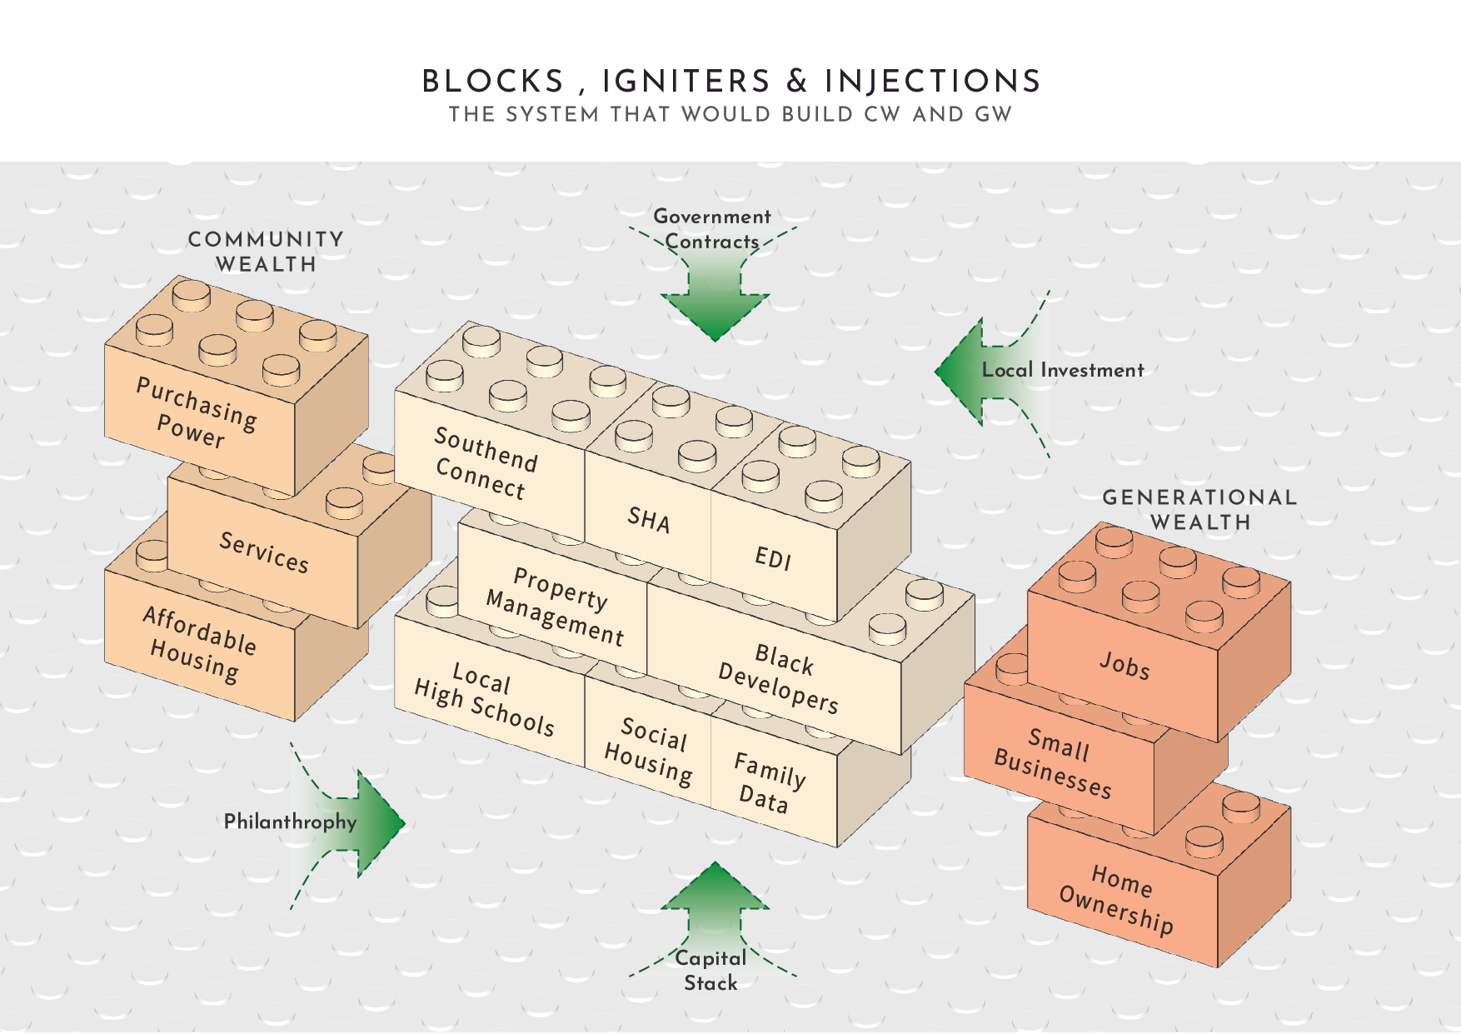  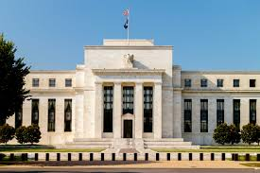  A LocaL Fed Bank Supporting The Brighton Nieghborhood economy | Abstract  A Local Fed Bank would give neighborhoods their own liquidity backstops, aggressive lending capacity, and oversight—on par with national central banks—so community-driven development can move quickly and withstand downturns. It would offer a discount window, crisis liquidity lines, and securitization support—backed by guarantee pools and philanthropic credit—to finance land acquisitions, projects, and social enterprises responsibly. Governed by residents, nonprofits, and public officials with transparent audits, it embeds financial discipline and social impact at the core of the chaordic network.

Introduction
Robust, self-sustaining neighborhoods require more than the sum of individual developments or social services; they demand a financial architecture capable of providing deep liquidity, countercyclical support, and reliable oversight equivalent to the “too big to fail” safety nets available to large institutions. While national central banks and federal guarantors underpin major banks and corporations, local economies—particularly those structured as chaordic, community-led networks—lack a comparable backstop. To reverse displacement, build generational wealth, and ensure continuity through market cycles, neighborhoods must establish a Local Federal Bank: an entity empowered to serve as lender of last resort, liquidity provider, and regulator for hyper-local economic systems.

The Case for a Local Fed Bank
1. Addressing Systemic Liquidity Gaps
Traditional community lenders and CDFIs (Community Development Financial Institutions) often face capital constraints during downturns, limiting their ability to finance critical projects or refinance troubled assets. A Local Fed Bank would hold capital reserves and access to credit lines—sourced from philanthropic endowments, municipal bonds, and private wealth funds—to inject liquidity when market conditions tighten. This mechanism parallels the Federal Reserve’s discount window but is tailored to neighborhood scales and geographies.
2. Enabling Aggressive, Countercyclical Lending
To capture land before external speculators drive up prices, neighborhoods must act swiftly and at scale. A dedicated Local Fed Bank can underwrite bold acquisitions—fronting 80–100% of land costs—and syndicate funding to community partners, ensuring rapid deployment of capital. By taking a long-term view, it can offer flexible amortization schedules and interest-only periods aligned with project cash flows, reducing barriers for smaller developers and co-ops.
Core Functions and Mechanisms
1. Discount Window for Neighborhood Projects
Similar to the Federal Reserve’s primary credit facility, the Local Fed Bank would provide short-term loans at near-cost to community-led ventures—ranging from multi-family rehabilitations to small-business incubators. This facility alleviates cash-flow mismatches, enabling project teams to pay contractors promptly and maintain momentum.
2. Liquidity Facilities During Crises
In economic stress—such as a construction downturn or a public health emergency—the bank can activate standby liquidity lines to shore up existing mortgages, property management firms, and social enterprises. These lines would be pre-arranged and collateralized by pooled assets across the network, allowing rapid drawdowns without protracted approval processes.
3. Refinancing and Securitization Support
Longer-term financing needs—like converting property management cash flows or equity stakes into standardized debt instruments—can be facilitated by the bank’s ability to bundle and securitize loans. This function creates a secondary market for neighborhood assets, attracting responsible external investors while keeping ultimate control within the community network.

Integration with Community Networks
The Brighton Communities chaordic network—comprised of over 200 individuals and 125 organizations—demonstrates how decentralized structures can mobilize multi-project portfolios in parallel, from housing to green technology to small business development …. A Local Fed Bank embeds within this network as the financial heart, aligning incentives across subgroups:
- Development Cohorts launch property acquisitions with immediate capital.
- Service Partners secure lines for social enterprises and senior services.
- Technical Teams draw on credit to innovate green infrastructure.
- Policy and Oversight Bodies monitor financial health, ensuring alignment with shared community values.
By weaving financial services into the chaordic model, the Local Fed Bank enhances both speed (through distributed decision-making) and resilience (by centralizing risk management).
Loan Guarantees and Risk Management
1. Collective Guarantee Pools
Each borrower contributes to a pooled guarantee fund—an insurance mechanism underwriting 10–20% of principal for covered loans. In the event of default, this fund absorbs initial losses, protecting both smaller lenders and the bank’s capital base.
2. Credit Enhancement by Philanthropic Partners
Foundations, municipal treasuries, and private wealth funds can provide first-loss capital or letters of credit, boosting the credit rating of Local Fed Bank securities. This enhancement lowers borrowing costs and attracts institutional co-investors interested in blended-return structures
3. Underwriting Standards Aligned with Community Values
Risk assessments incorporate both financial and social metrics—such as job creation, resident representation, and environmental impact—ensuring that lending decisions reinforce equitable development. This blended underwriting approach balances strict financial controls with the network’s mission of shared prosperity
Governance and Oversight
1. Multi-Stakeholder Board
Governance rests with a board comprising local residents, technical experts, nonprofit leaders, and municipal representatives. This body sets lending policies, approves large credit lines, and monitors systemic risks, ensuring transparency and accountability.
2. Independent Audit and Regulatory Coordination
Quarterly independent audits verify capital adequacy, risk reserves, and social impact outcomes. The bank coordinates with city housing agencies, state regulators, and CDFI authorities to align with existing financial regulations while advocating for adaptive, neighborhood-level policy innovations.
3. Transparent Reporting to Network Members
An integrated digital platform—leveraging the coalition’s AI-driven feedback system—provides real-time dashboards on loan performance, guarantee fund status, and capital allocation. All network members can access summary reports, fostering collective oversight and rapid course corrections.
Conclusion
A Local Federal Bank represents the missing pillar in community-driven neighborhood development: the continuous, scalable financial backbone that matches the ambition of chaordic networks while mitigating systemic risk. By providing a discount window, liquidity facilities, securitization support, and robust guarantee mechanisms—governed by a multi-stakeholder board and transparent reporting—the bank empowers neighborhoods to act boldly, weather downturns, and sustain equitable growth. Just as the Federal Reserve underwrites national stability, a neighborhood-level Fed Bank underwrites local sovereignty, ensuring that communities can confidently buy, build, and own their own futures.
Call to Action: Who Will Step Up?
To transform this vision into reality, we need a champion—an institution or consortium willing to stand behind the Local Fed Bank as its founding backer and ongoing steward. Potential candidates include:
- Regional Government Bodies (e.g., city or metro‐area economic development authorities):
Your mandate is to foster local prosperity and equitable growth. By underwriting the initial capital reserves or offering a municipal liquidity line, you can catalyze community ownership at an unprecedented scale. This approach aligns with public goals around affordable housing, small‐business support, and anti‐displacement.
- Private Foundations and Wealth Funds:
With deep endowments and social‐impact mandates, foundations can seed the guarantee pools and provide first‐loss capital that unlocks low‐cost borrowing for dozens of neighborhood ventures. A wealth fund with an “impact tranche” could anchor the bank’s balance sheet, improving credit ratings and attracting co‐investors.
- Philanthropic Impact Investors:
You understand that sustainable, long-term returns require resilient, community-driven models. By investing in the Local Fed Bank’s capital stack—through equity-like subordinated notes or program‐related investments—you’ll both secure financial returns and ensure that wealth circulates within the neighborhood economy.
- Consortium of Corporate Partners:
Major employers and local businesses can join forces to underwrite the discount window, collateralize liquidity facilities, and contribute to underwriting technical assistance for borrowers. This partnership demonstrates corporate responsibility while anchoring local supply chains and workforce pipelines.
Imagine a regional economic development agency launching the Local Fed Bank with an inaugural $50 million capitalization, matched by a coalition of foundations and impact investors. Within months, dozens of parcels are secured, dozens of small developers and co-ops tap into low-cost financing, and the first hardship loans cushion landlords and tenants during an economic downturn. This is not hypothetical—it mirrors how central banks stabilized national credit markets in 2008. Now, it’s time to bring that same muscle to the neighborhood level.

